The effect of wind load
Motion | Tp(s) | f(rad/s)
Surge | 115 | 0.055
Sway | 125 | 0.05
Heave | 31.4 | 0.2
Roll/pitch | 32.7 | 0.19
Yaw | 7.5 | 0.838

Cased 1 All blades are feathered， Wavedir=0, V=38.7, Hs=12, Tp=14.2 position1
Cased 2 All blades are feathered ， Wavedir=0,V=0, Hs=12, Tp=14.2 position1
Cased 3 Blade2 seized， Wavedir=0, V=38.7, Hs=12, Tp=14.2 position1
Cased 4 Blade2 seized, Wavedir=0, V=0, Hs=12, Tp=14.2 position1
Cased 5 All blades are feathered， Wavedir=90, V=38.7, Hs=12, Tp=14.2 position1
Cased 6 All blades are feathered ， Wavedir=90, V=0, Hs=12, Tp=14.2 position1
Cased 7 Blade2 seized, Wavedir=90, V=38.7, Hs=12, Tp=14.2 position1
Cased 8 Blade2 seized， Wavedir=90, V=0, Hs=12, Tp=14.2 position1

Nacelle Surge
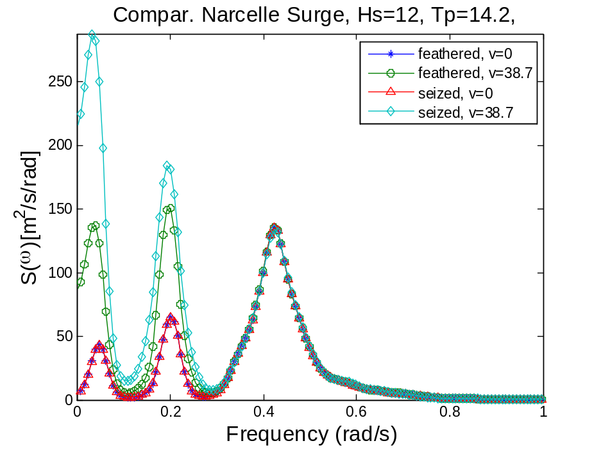
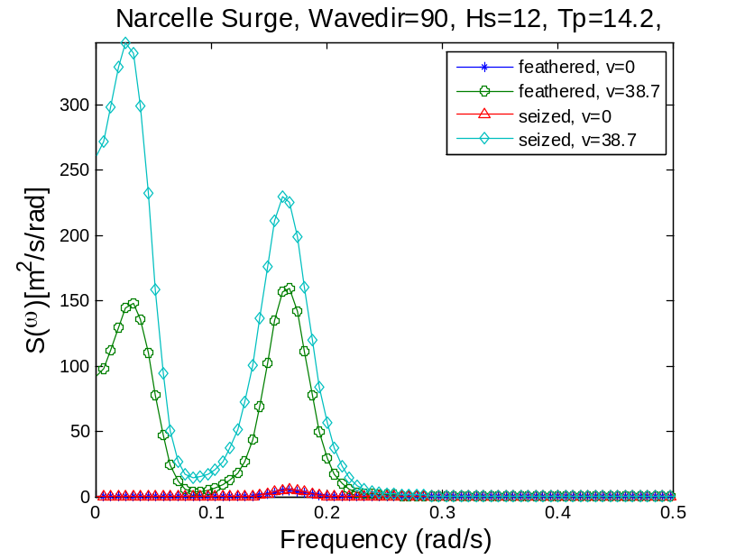
Nacelle Sway
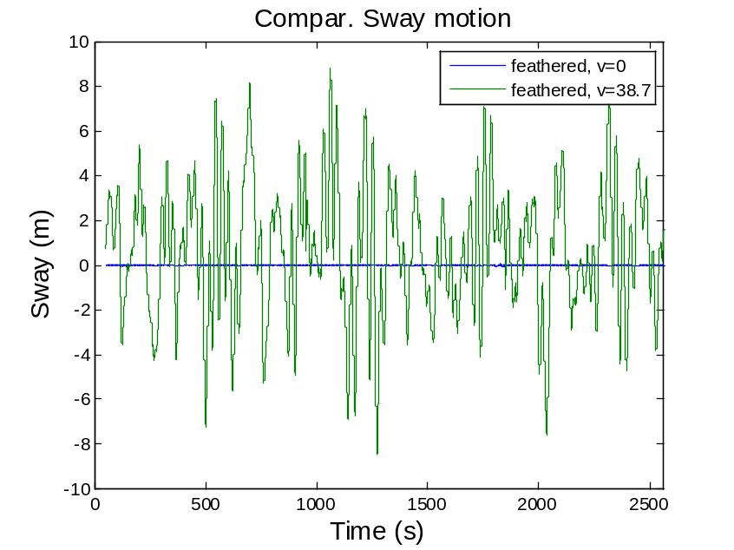
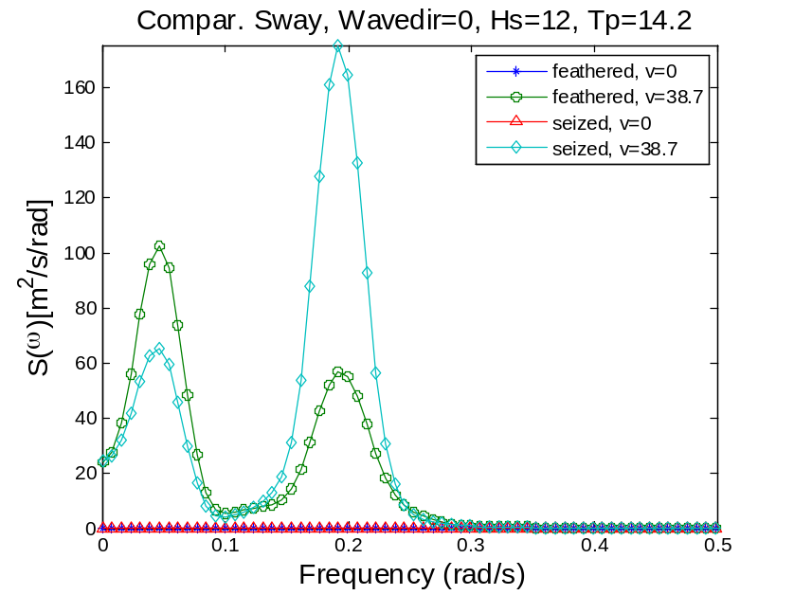
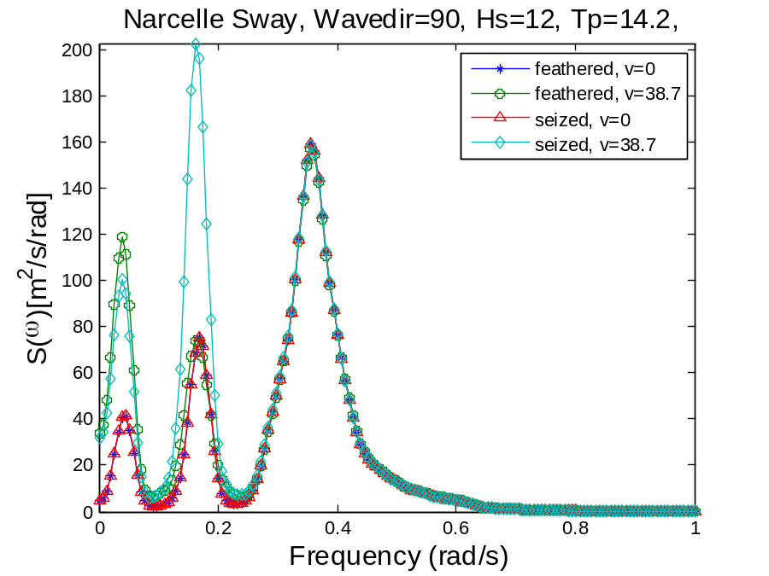
Roll
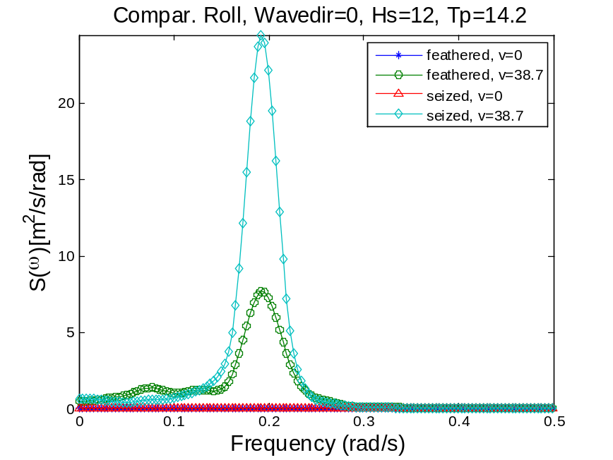
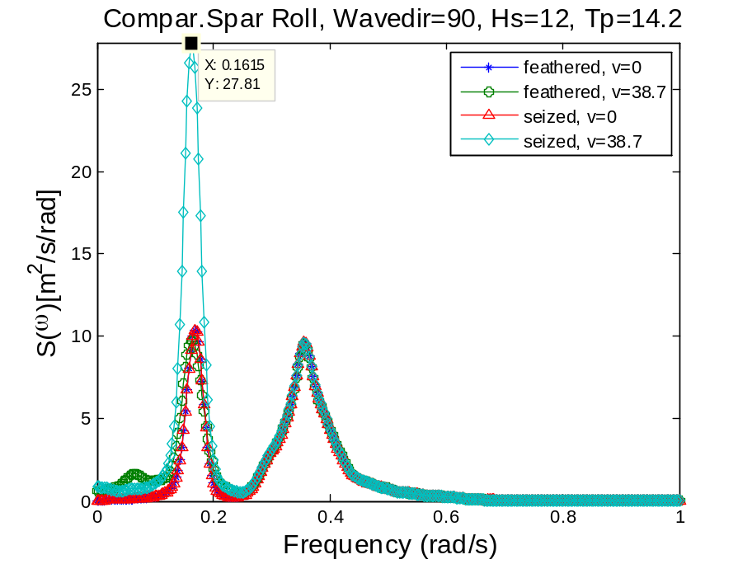
pitch
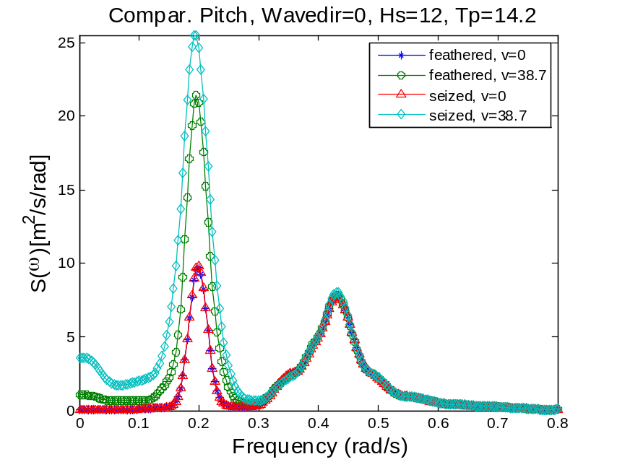
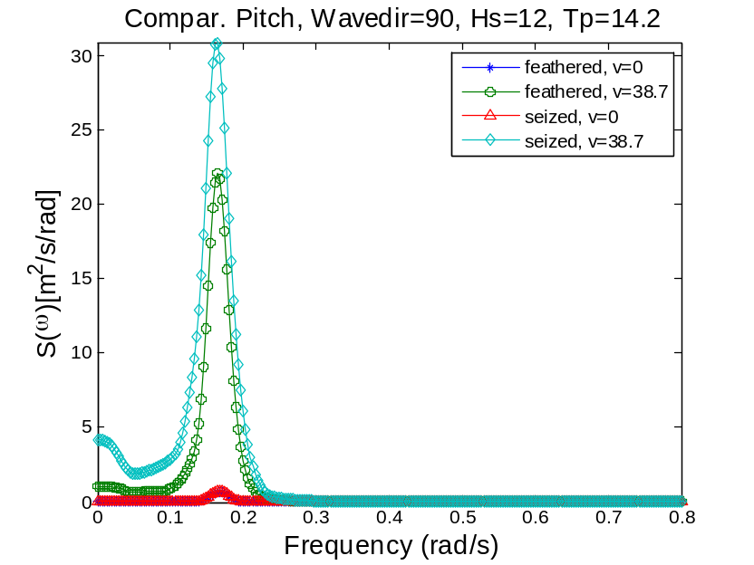
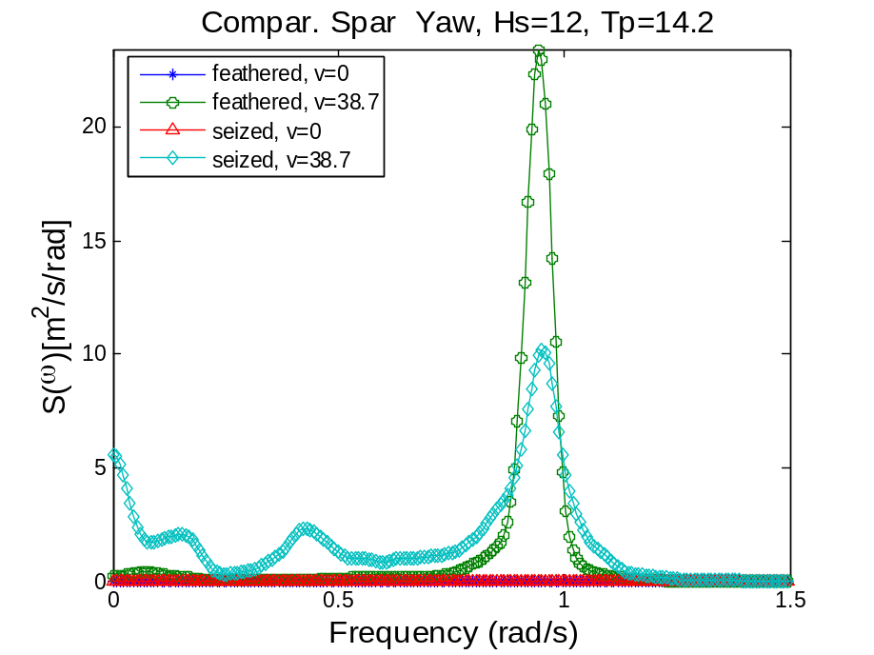
Mx
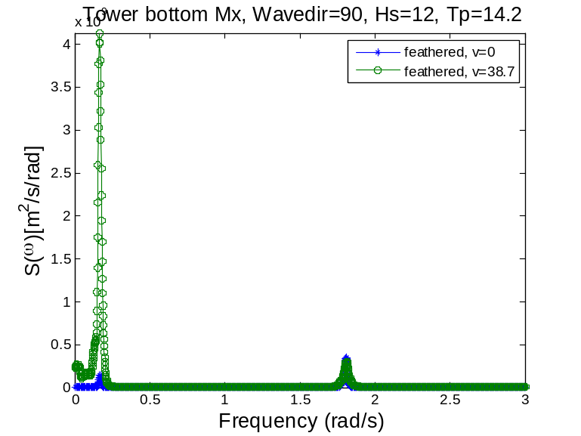
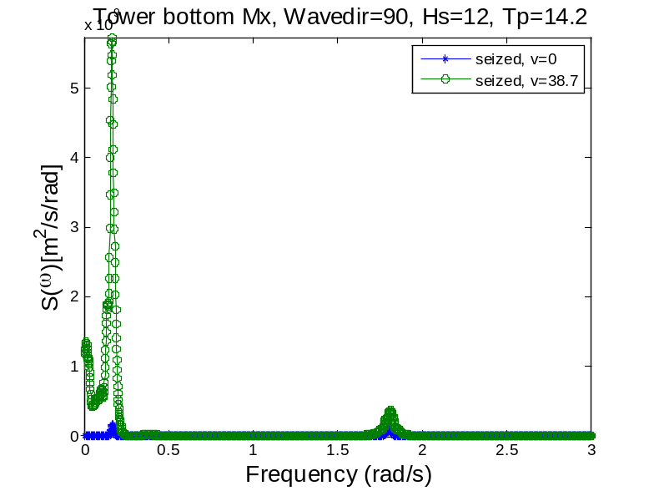
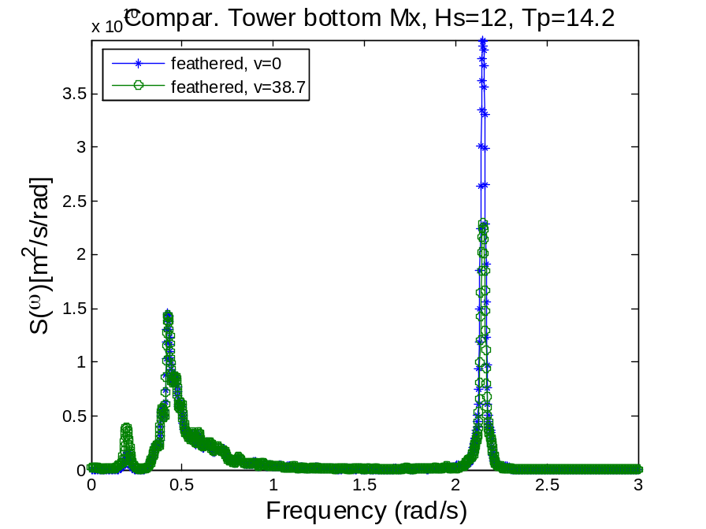
The wave loading contributes to the excitation of tower fore-aft bending. The aerodynamic damping help reduce the peak of the elastic resonance response.
Std.v0=60586
Std.v0=56754
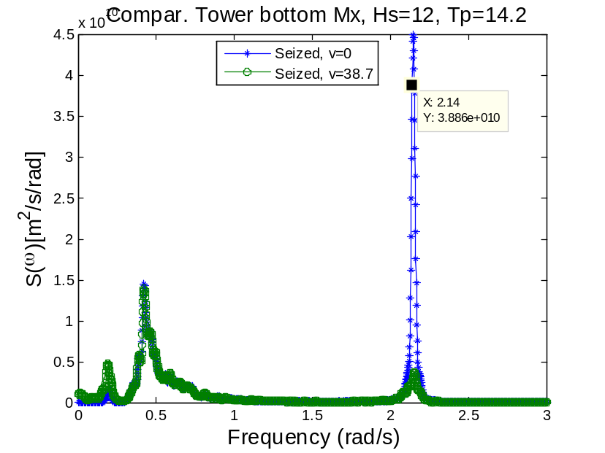
The aerodynamic damping offered by the seized blade is beneficial in lowering the fore-aft resonance present in the tower root bending moment Mx, dissipating certain amount of energy.
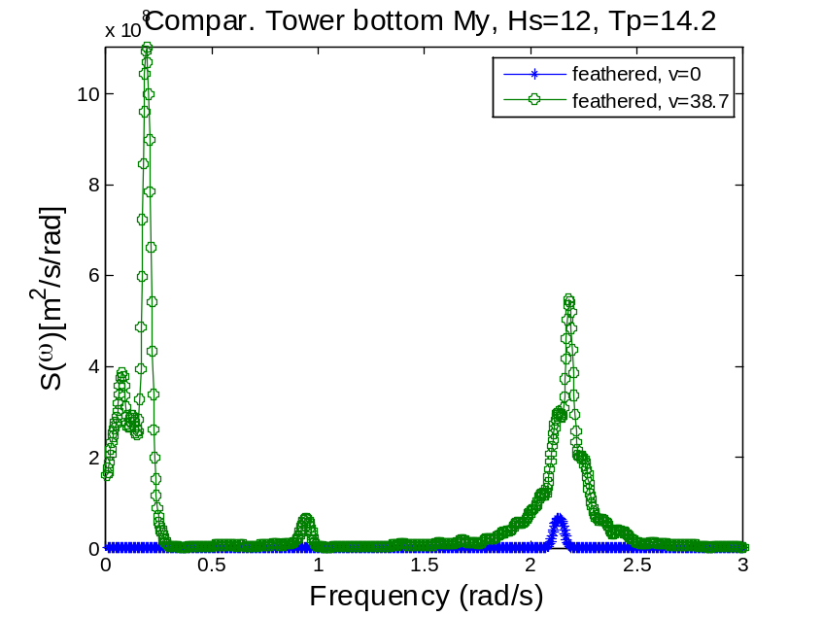
Since there are more low-frequency wind coming in the direction of –x, larger resonant responses are excited compared with the seized case.
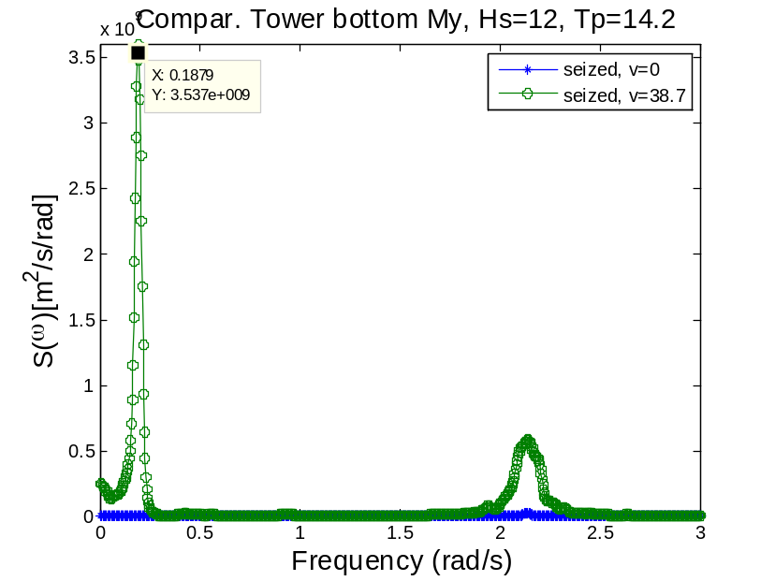
Wp1=0.19, roll resonance wp2=2.14, side to side elastic response of tower
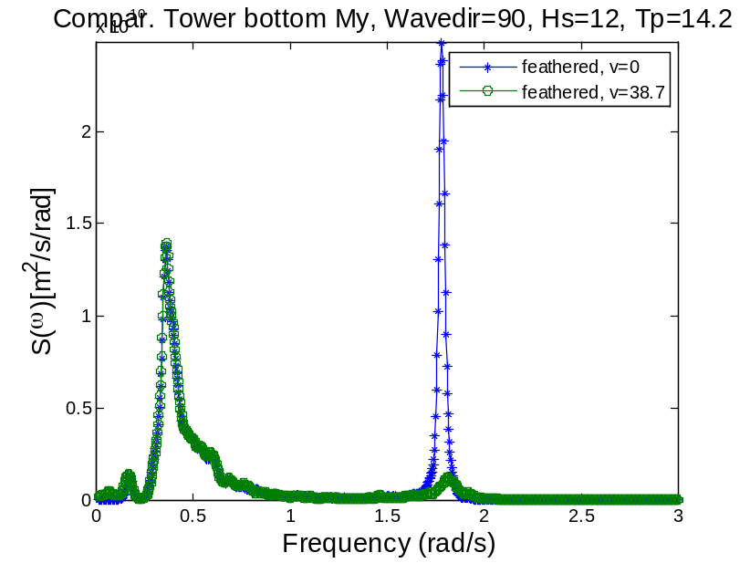
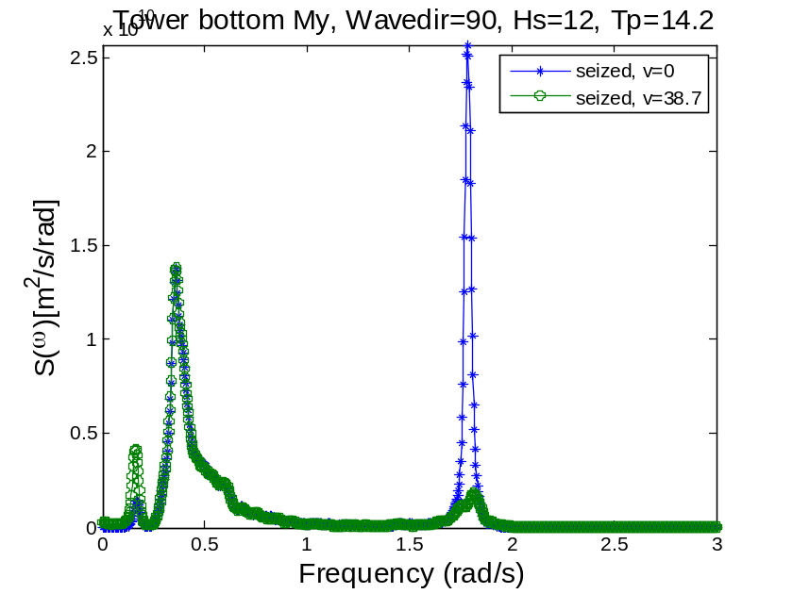
It is the wind that excites the roll motion and the resonant response of My. When blade2 is seized and flat to the wind, the lift load in –x direction decreases leading to a lower peak compared with the feathered cases.
Fy: similar to Mx
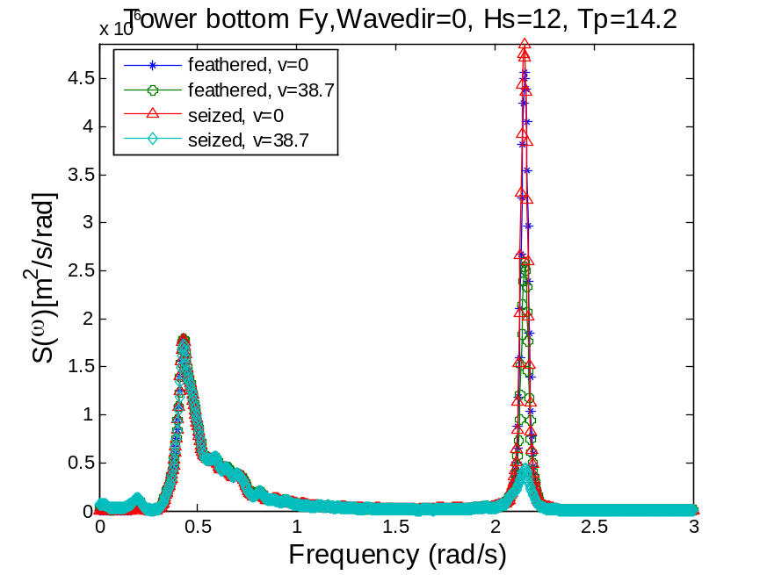
A small disturbance created by the wind will excite the first natural frequency resonance of the shear force response. If the disturbance is collinear with the wave force, this comparatively large load would damp out the resonance.
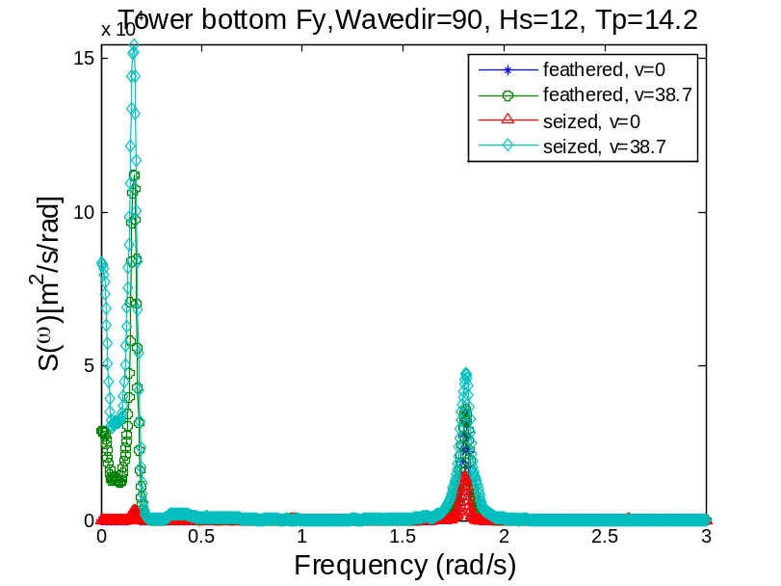
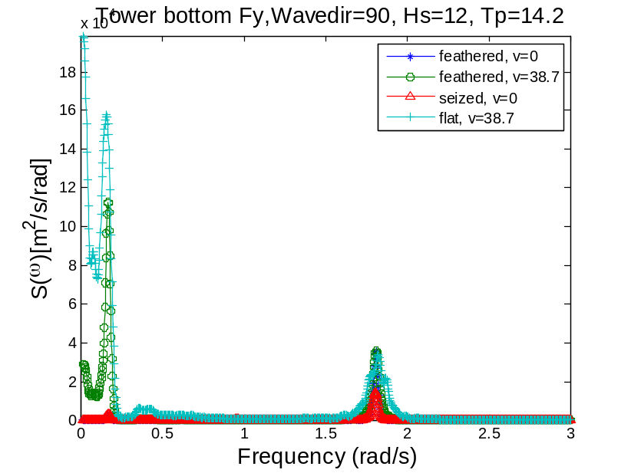
When there is only wave with direction 0 deg, the response is dominated by the first tower fore-aft mode. The wind in the same direction of wave would create a slight drag load in –y direction and a comparatively large lift in –x direction. The drag would result in a low-frequency thrust which does not affect the response of tower shear force much. The hydrodynamic loads of the seized case vary very differently from the feathered case, affecting the shear force directly. When wave direction is 0 deg, the reponse of the tower bottom resembles that of the hydrodynamic loading. The small fluctuating Drag in –y would damp out the wave load effect which gives rise to the first tower fore-aft mode. When the wave direction is 90 deg, there would be minimal wave load in –y direction. The small fluctuating aerodynamic drag alone would excite the pitch resonance peak at 0.2 rad/s in the response of Fy.

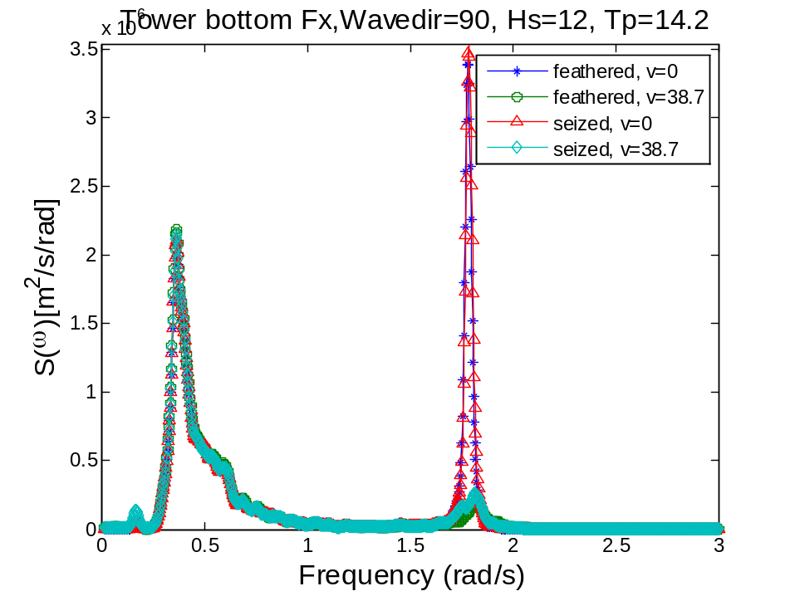
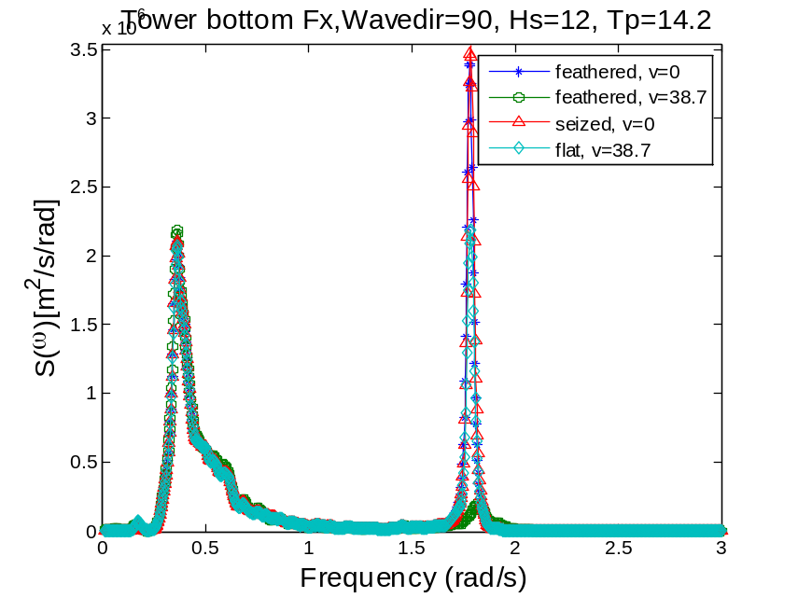
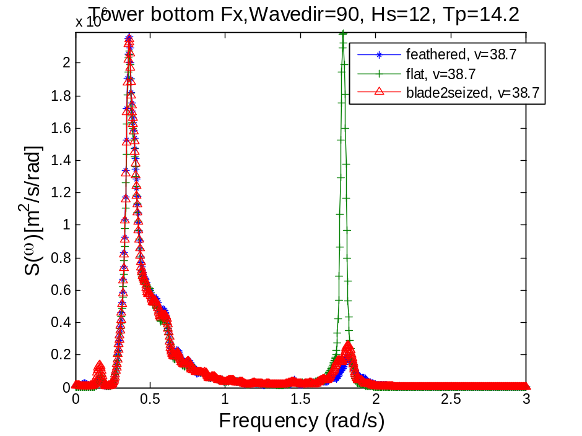
If wave direction is 90 deg, the wave load is in the direction of –x mainly. The feathered case or the blade2siezed case would have a comparatively large aerodynamic damping in the –x direction which produce low peaks around the first side-to-side natural frequency of the tower. If all of the blades are flat and there is no aerodynamic damping in –x direction, there would be very peaked response. For a floating wind turbine with blades braked to stop, The general conclusion is, if the aerodynamic loads from the blades are in the same direction of wave loads, damped resonance will be observed around the first tower natural mode. If the aerodynamic loads or wave loads act alone on the body, large resonance is likely to occur.

